CENG3420 Lab2 Report

Name: Chow Man Fung SID: 1155176920

Lab2.1

Steps

For I-type instructions, first set the op-code and func3 by shifting hexadecimal constant. Then, use reg_to_num() to turn the first and the second argument to the address of destination and source registers. Finally, use validate_imm() to validate the third argument, which is the immediate value; or use lower5bit() for shift instructions to extract the first five bits of the immediate value.

For R-type instructions, first set the op-code, func3 and func7 by shifting hexadecimal constant. Then, use reg_to_num() to turn the three arguments to the address of the destination, source1 and source 2 registers respectively.

For JAL, use handle_label_or_imm() to turn the second argument into the address of the label. Then use and operation to mask the right bits and shift them to the right place.

For JALR, use parse_regs_indirect_addr() to parse the value inside the register into the address of the programme.

For Branching instructions, similar to JAL, use label_to_num() to turn the third argument into the address of the label. Then use and operation to mask the right bits and shift them to the right place.

For Load and Store instructions, similar to JALR, use parse_regs_indirect_addr() to parse the value inside the register into the address of the memory. Then mask and shift the bits to the right position.

Main Code

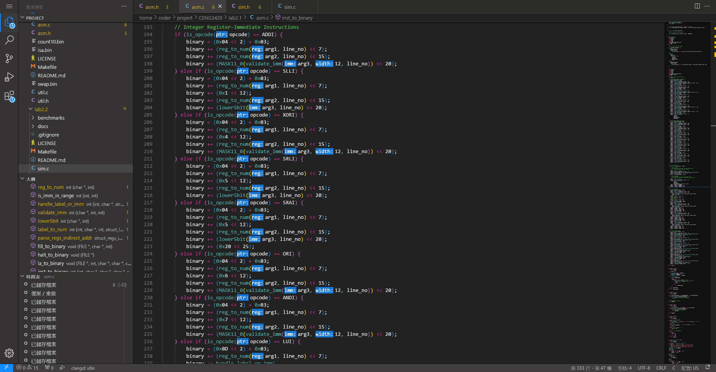

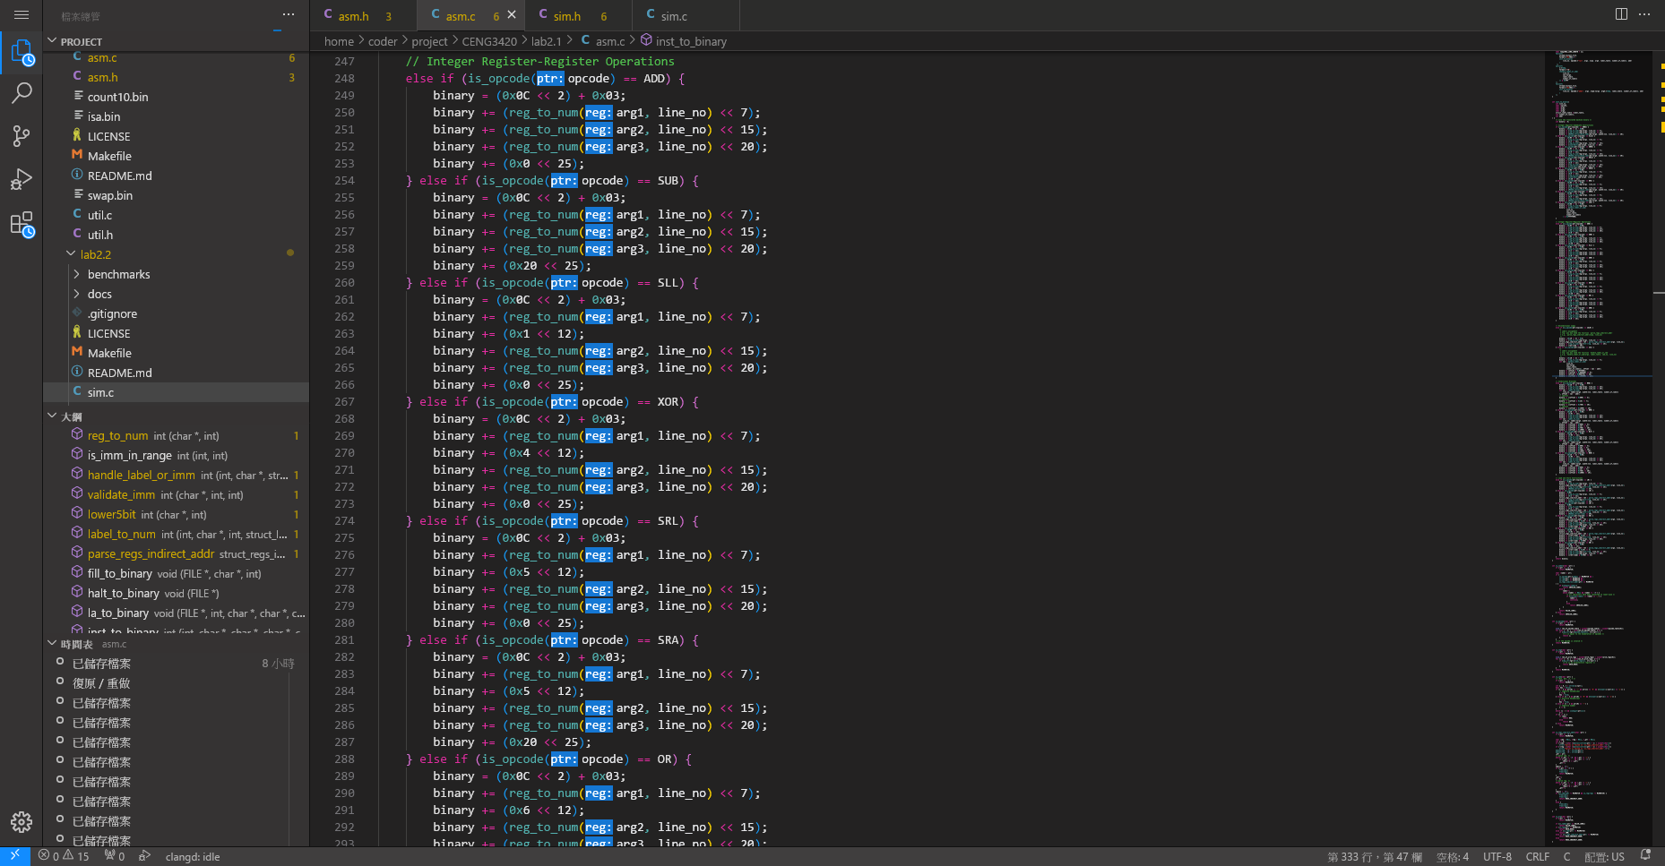

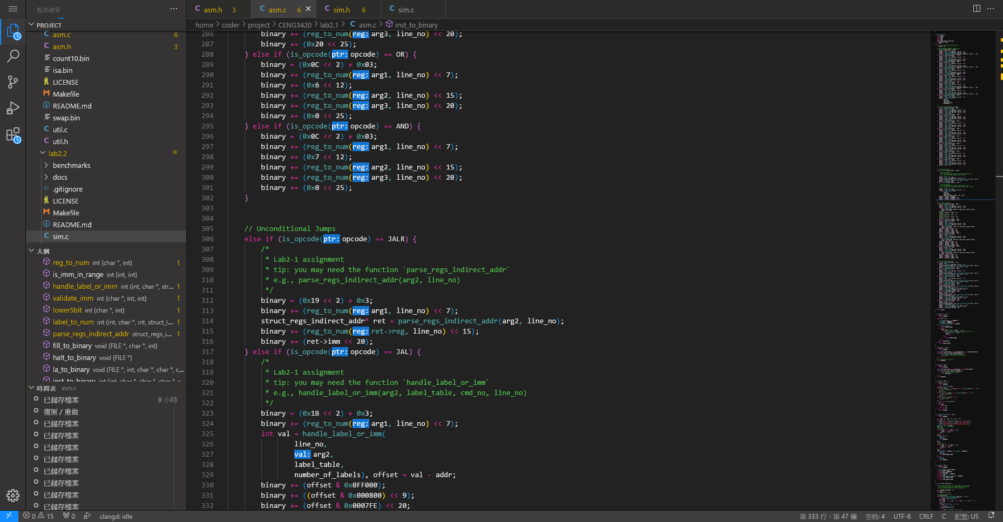

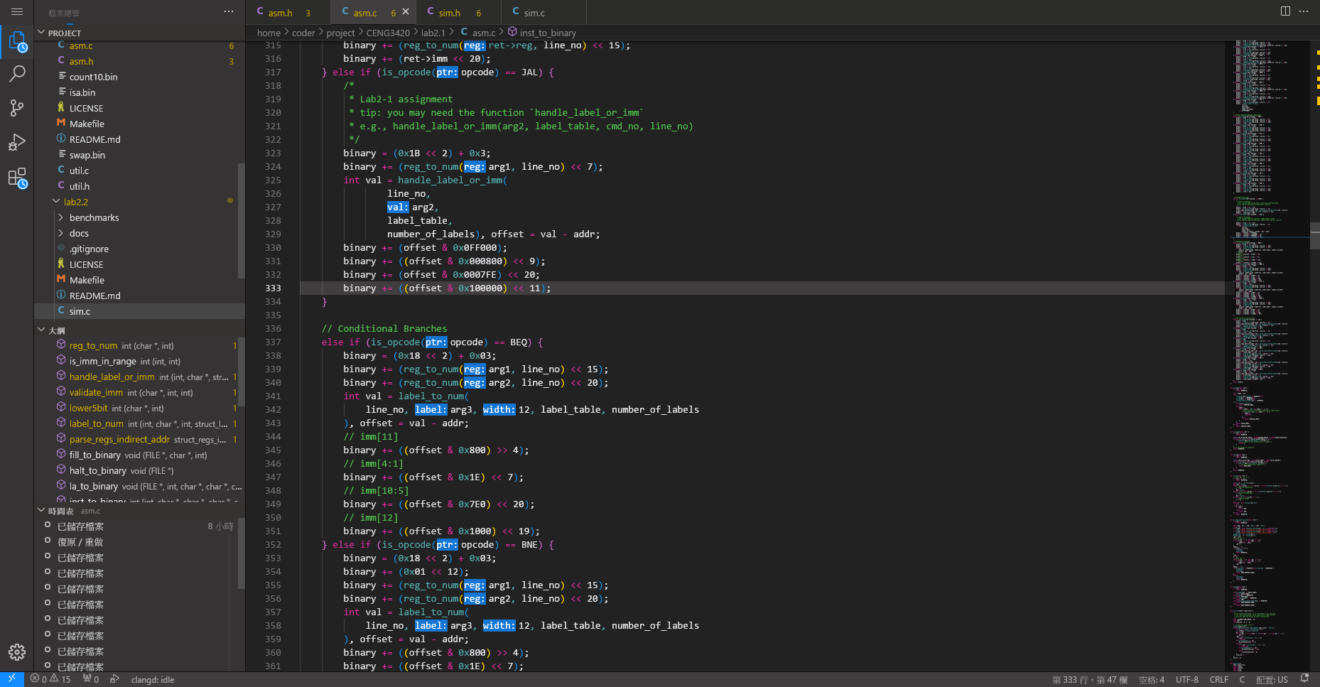

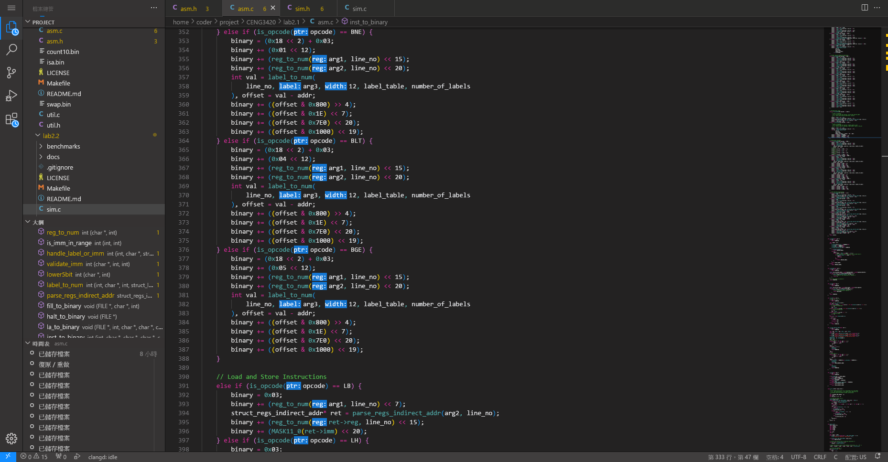

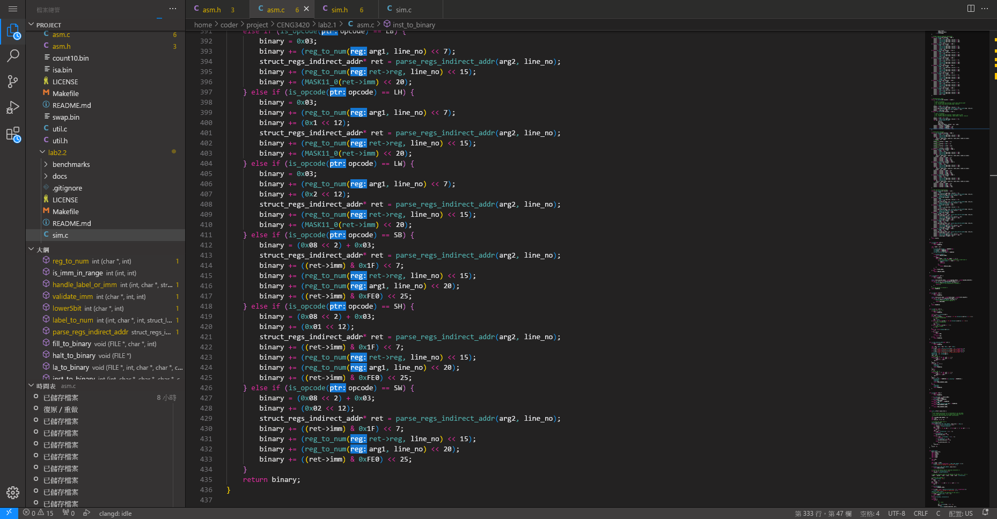

Console Output

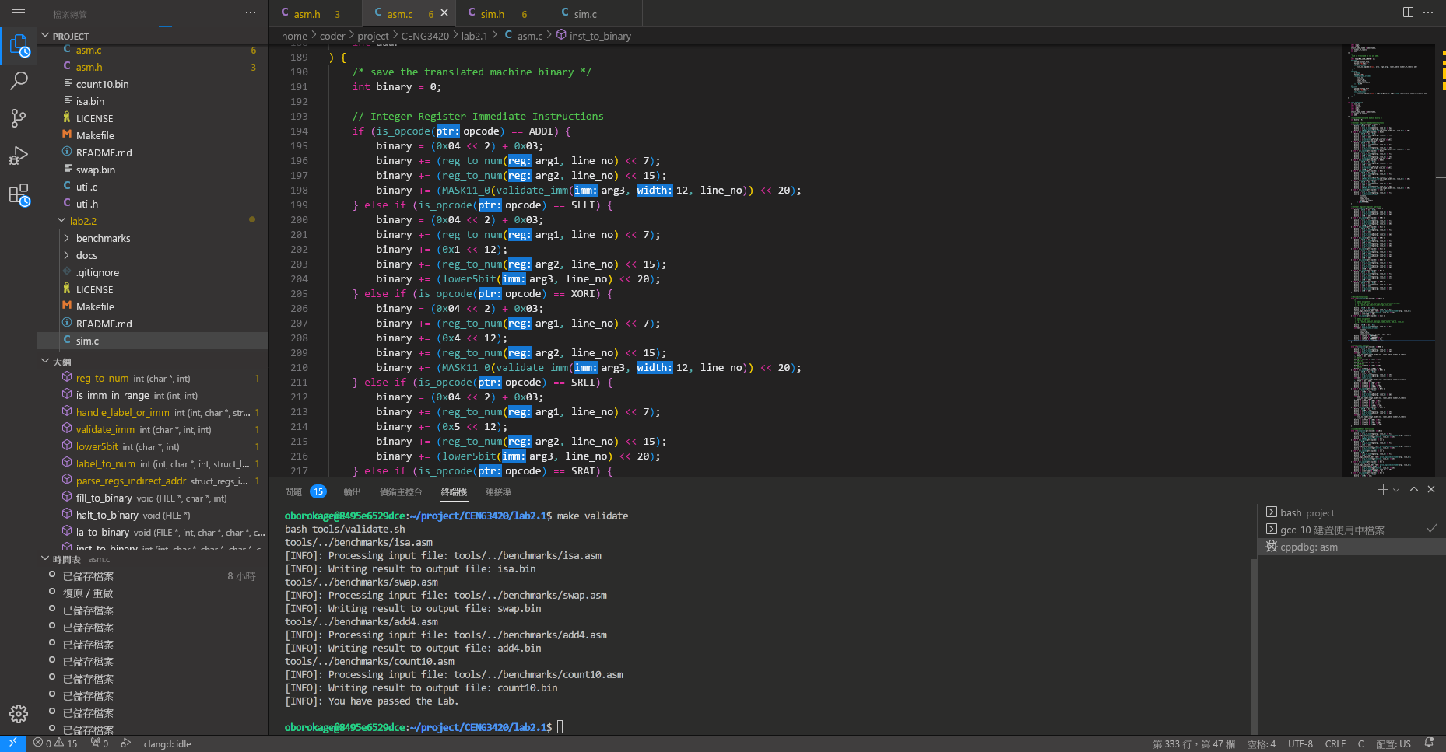

Lab2.2

Steps

For I-type instructions, mask the 7th-11th, 15th-19th and the 20th-31st bit to be the destination register, source register and the immediate value respectively. Then, do the respective operation to the current latches source register and the immediate value and store the result in the next latches destination register.

For lui instruction, mask the 7th-11th bit and the 12th-31st bit be the destination register and the immediate value. Then store the value into the next latches destination register.

For R-type instructions, mask the 7th-11th, 15th-19th, 20th-24th bit to be destination register, source register 1 and source register 2 respectively. Do the respective operations to the two current latches source registers and save the result in the next latches destination register.

For jalr, mask the 7th-11th, 15th-19th, and 12th-31st bit to be the destination register, source register and the immediate value. Save the current pc + 4 in the next latches destination register and set the next latches pc be current latches pc + the immediate value.

For jal, similar to jalr but replace one of the source register with the current latches pc.

For B-type instructions, similar to jal but adding a if branch before jumping (setting the next latches pc).

For lb/lh/lw, mask the 7th-11th, 15th-19th and the 20th-31st bit to be the destination register, the source register and the immediate value. Add the source register and the immediate value together and they become the address. Load the memory of the address and save it into the next latches destination register.

For sb/sh/sw, it is similar to lb/lh/lw but with reverse operation.

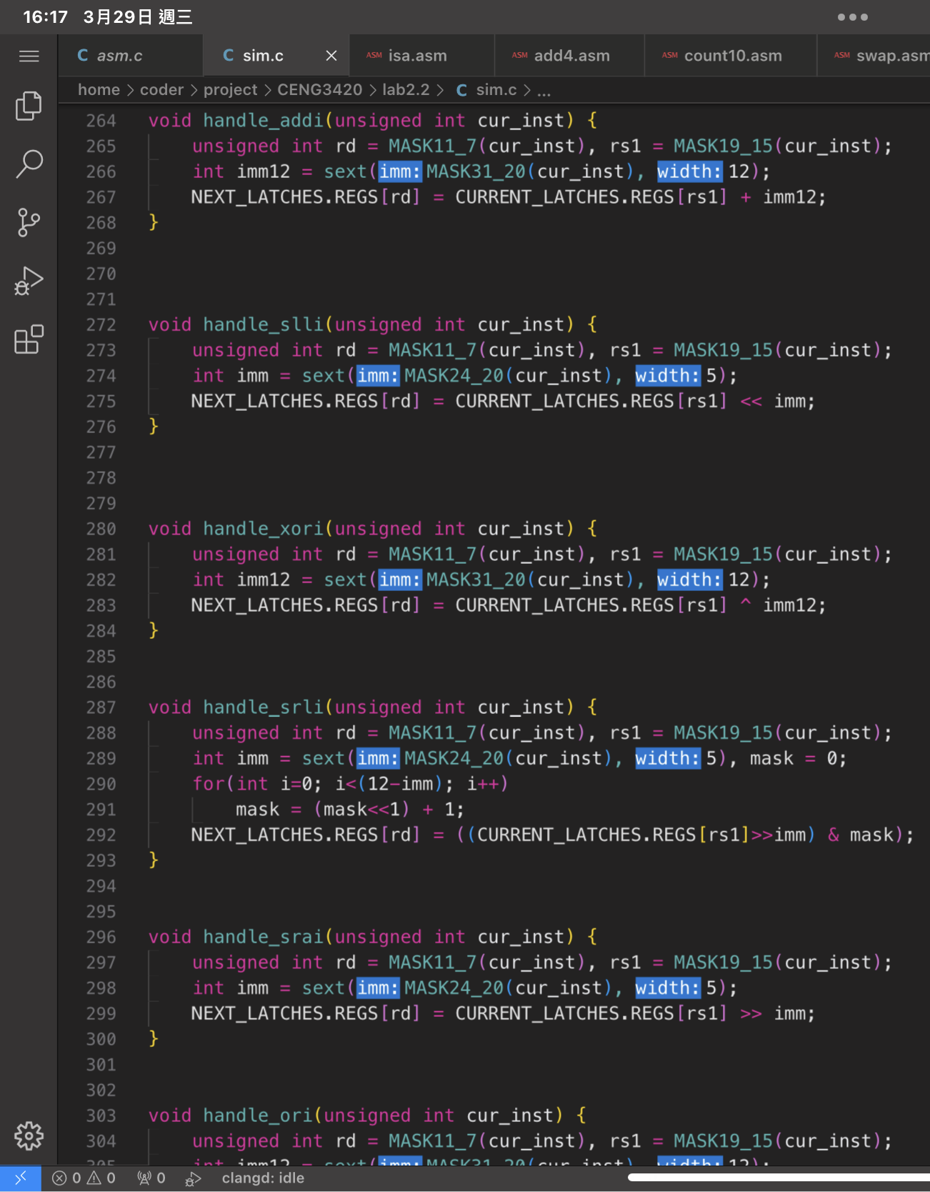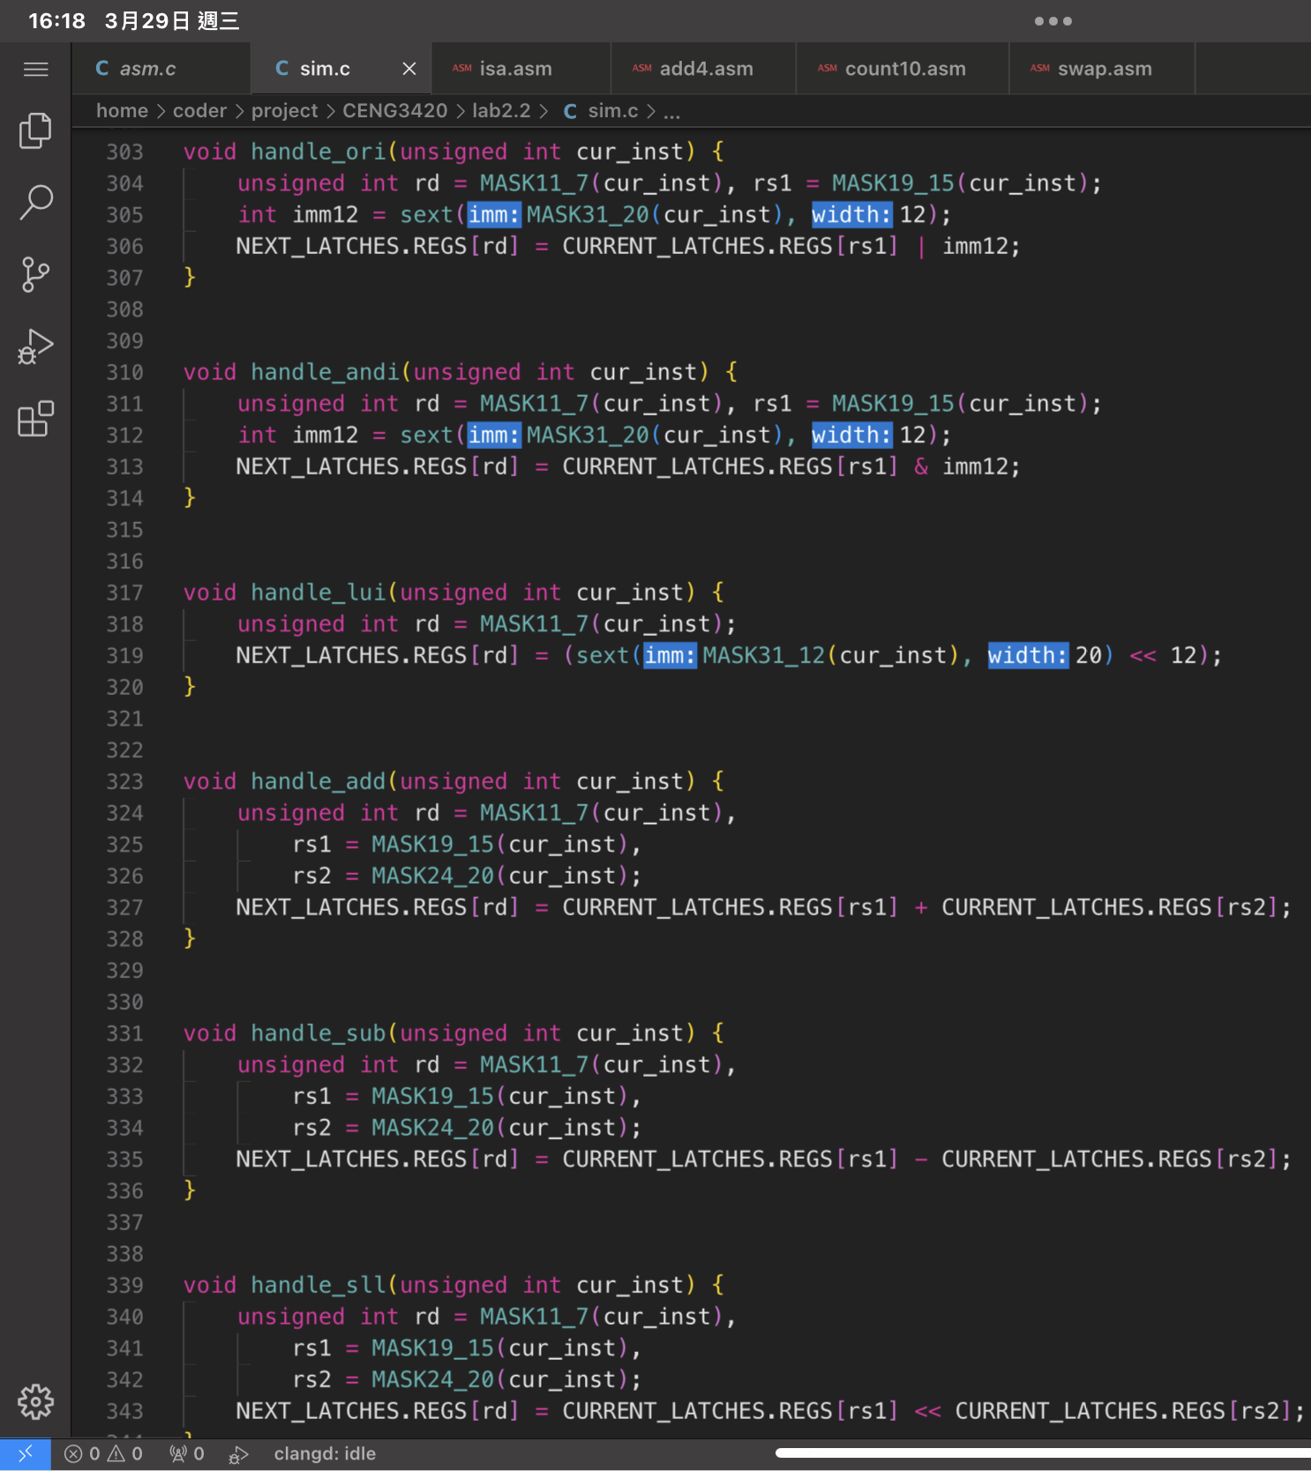Main Code

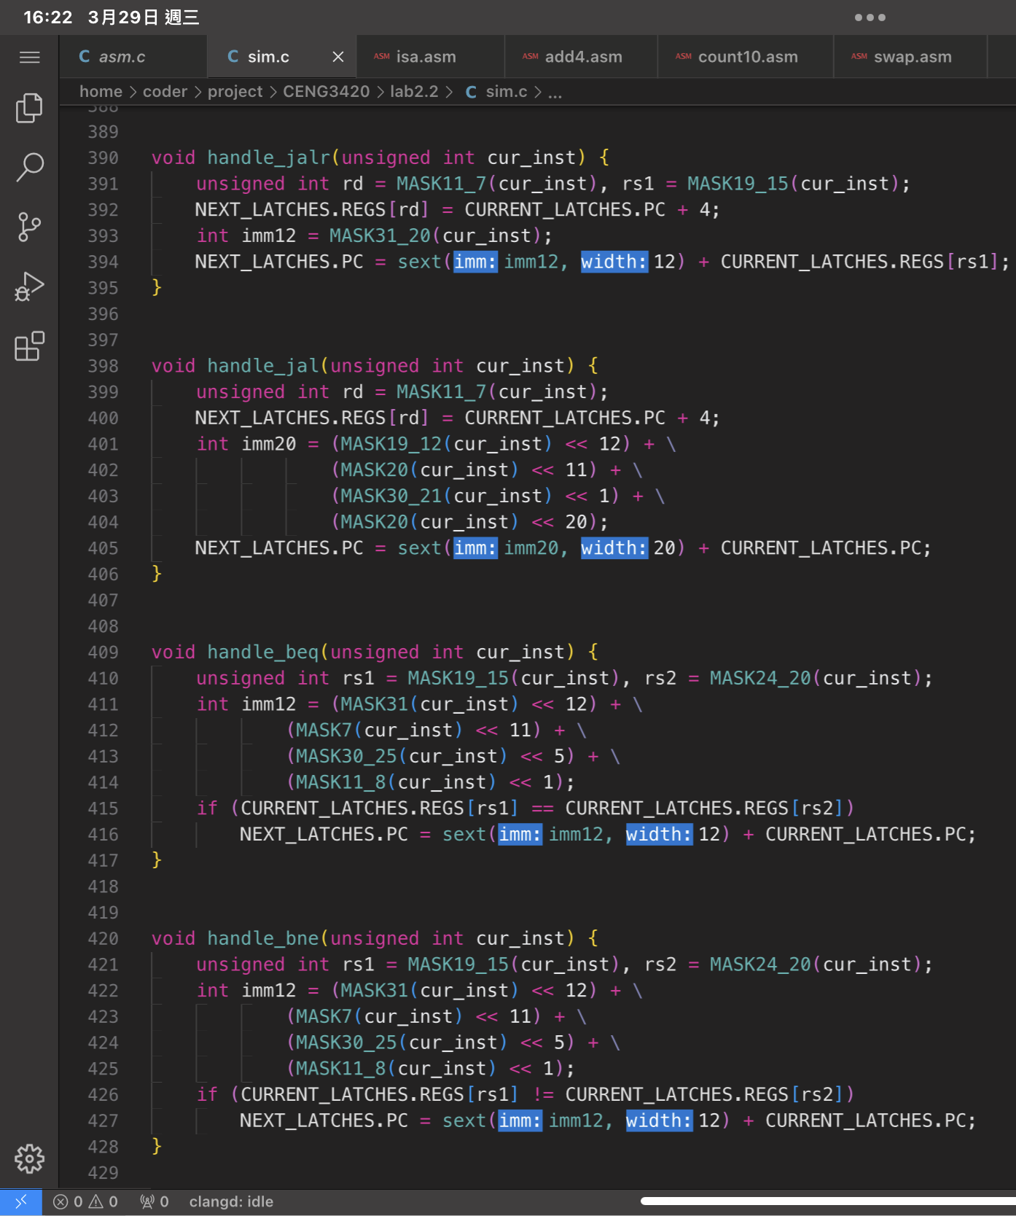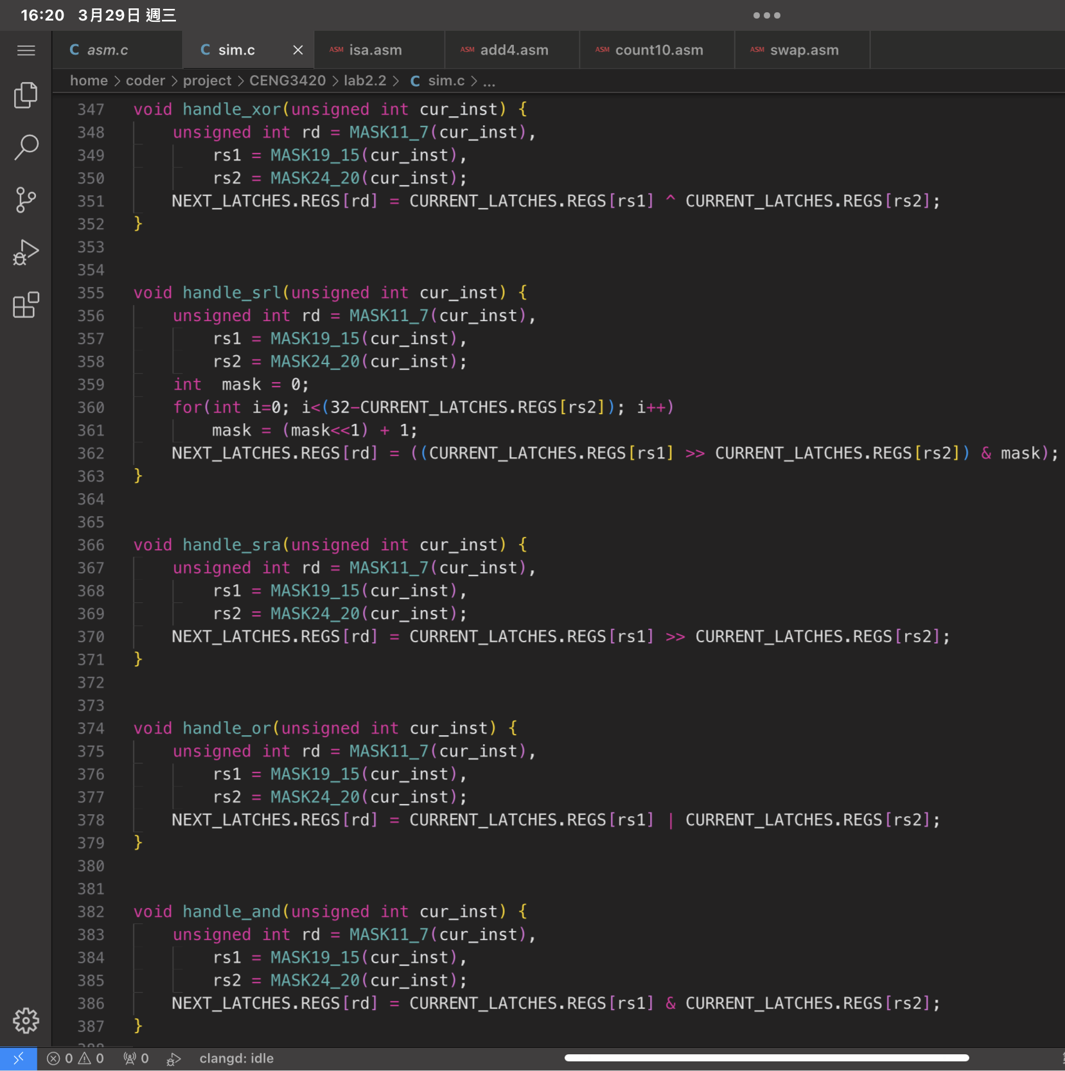

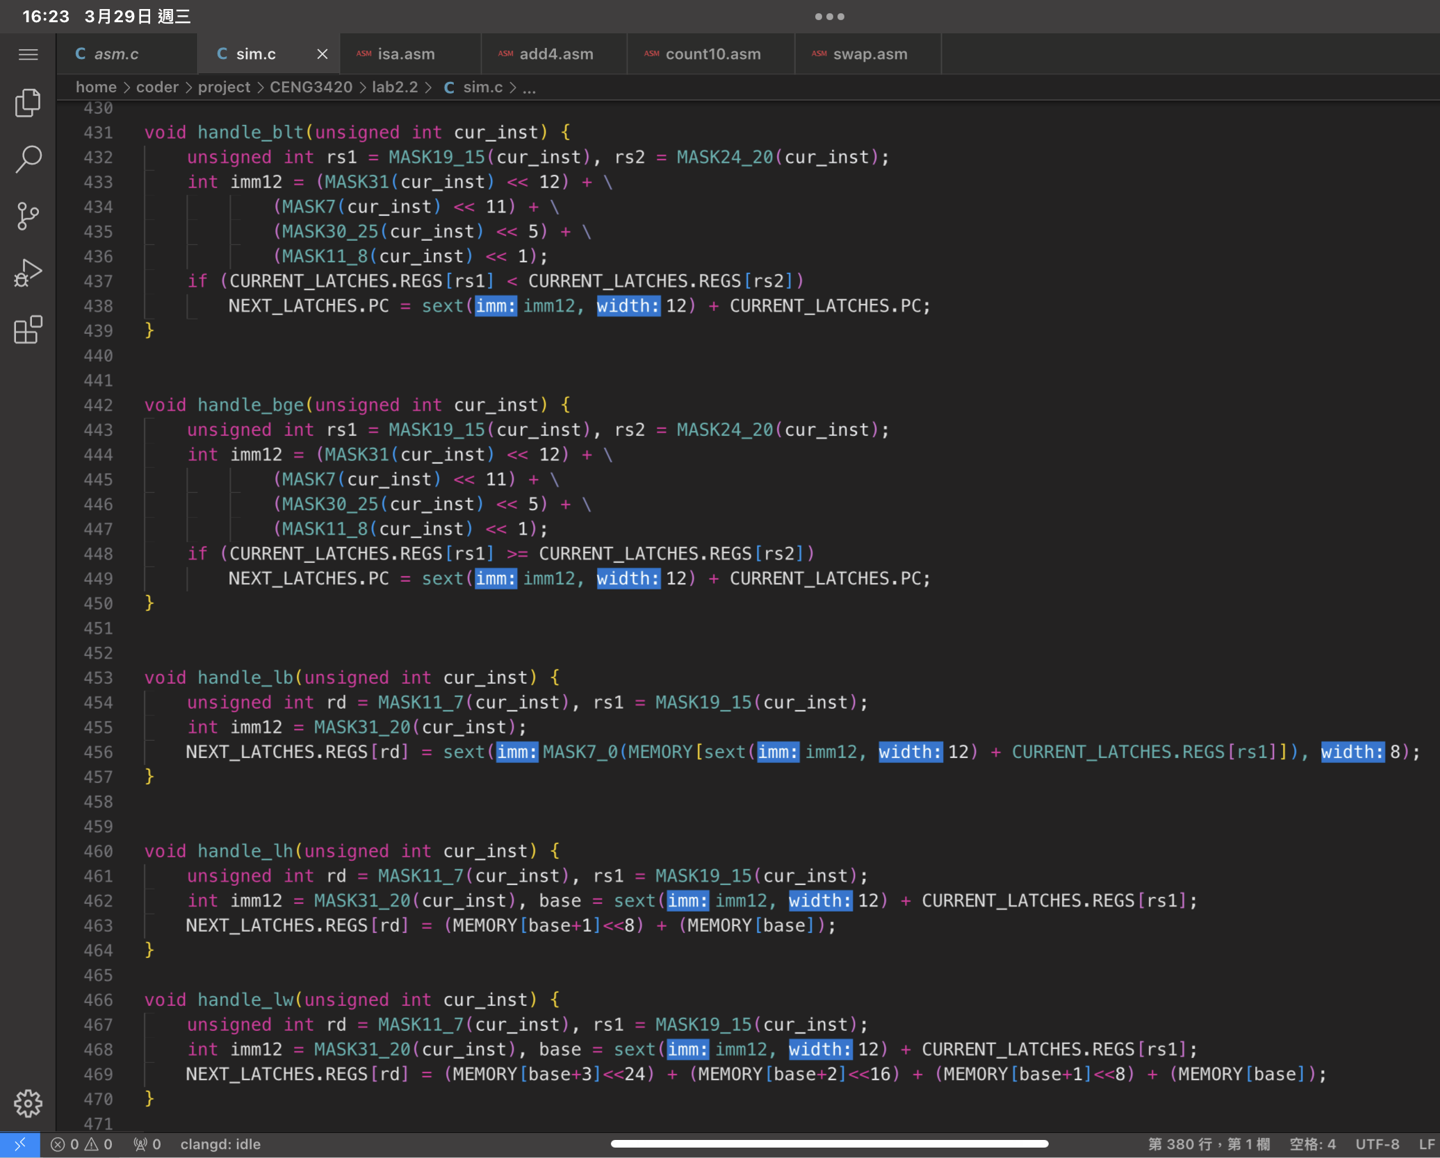

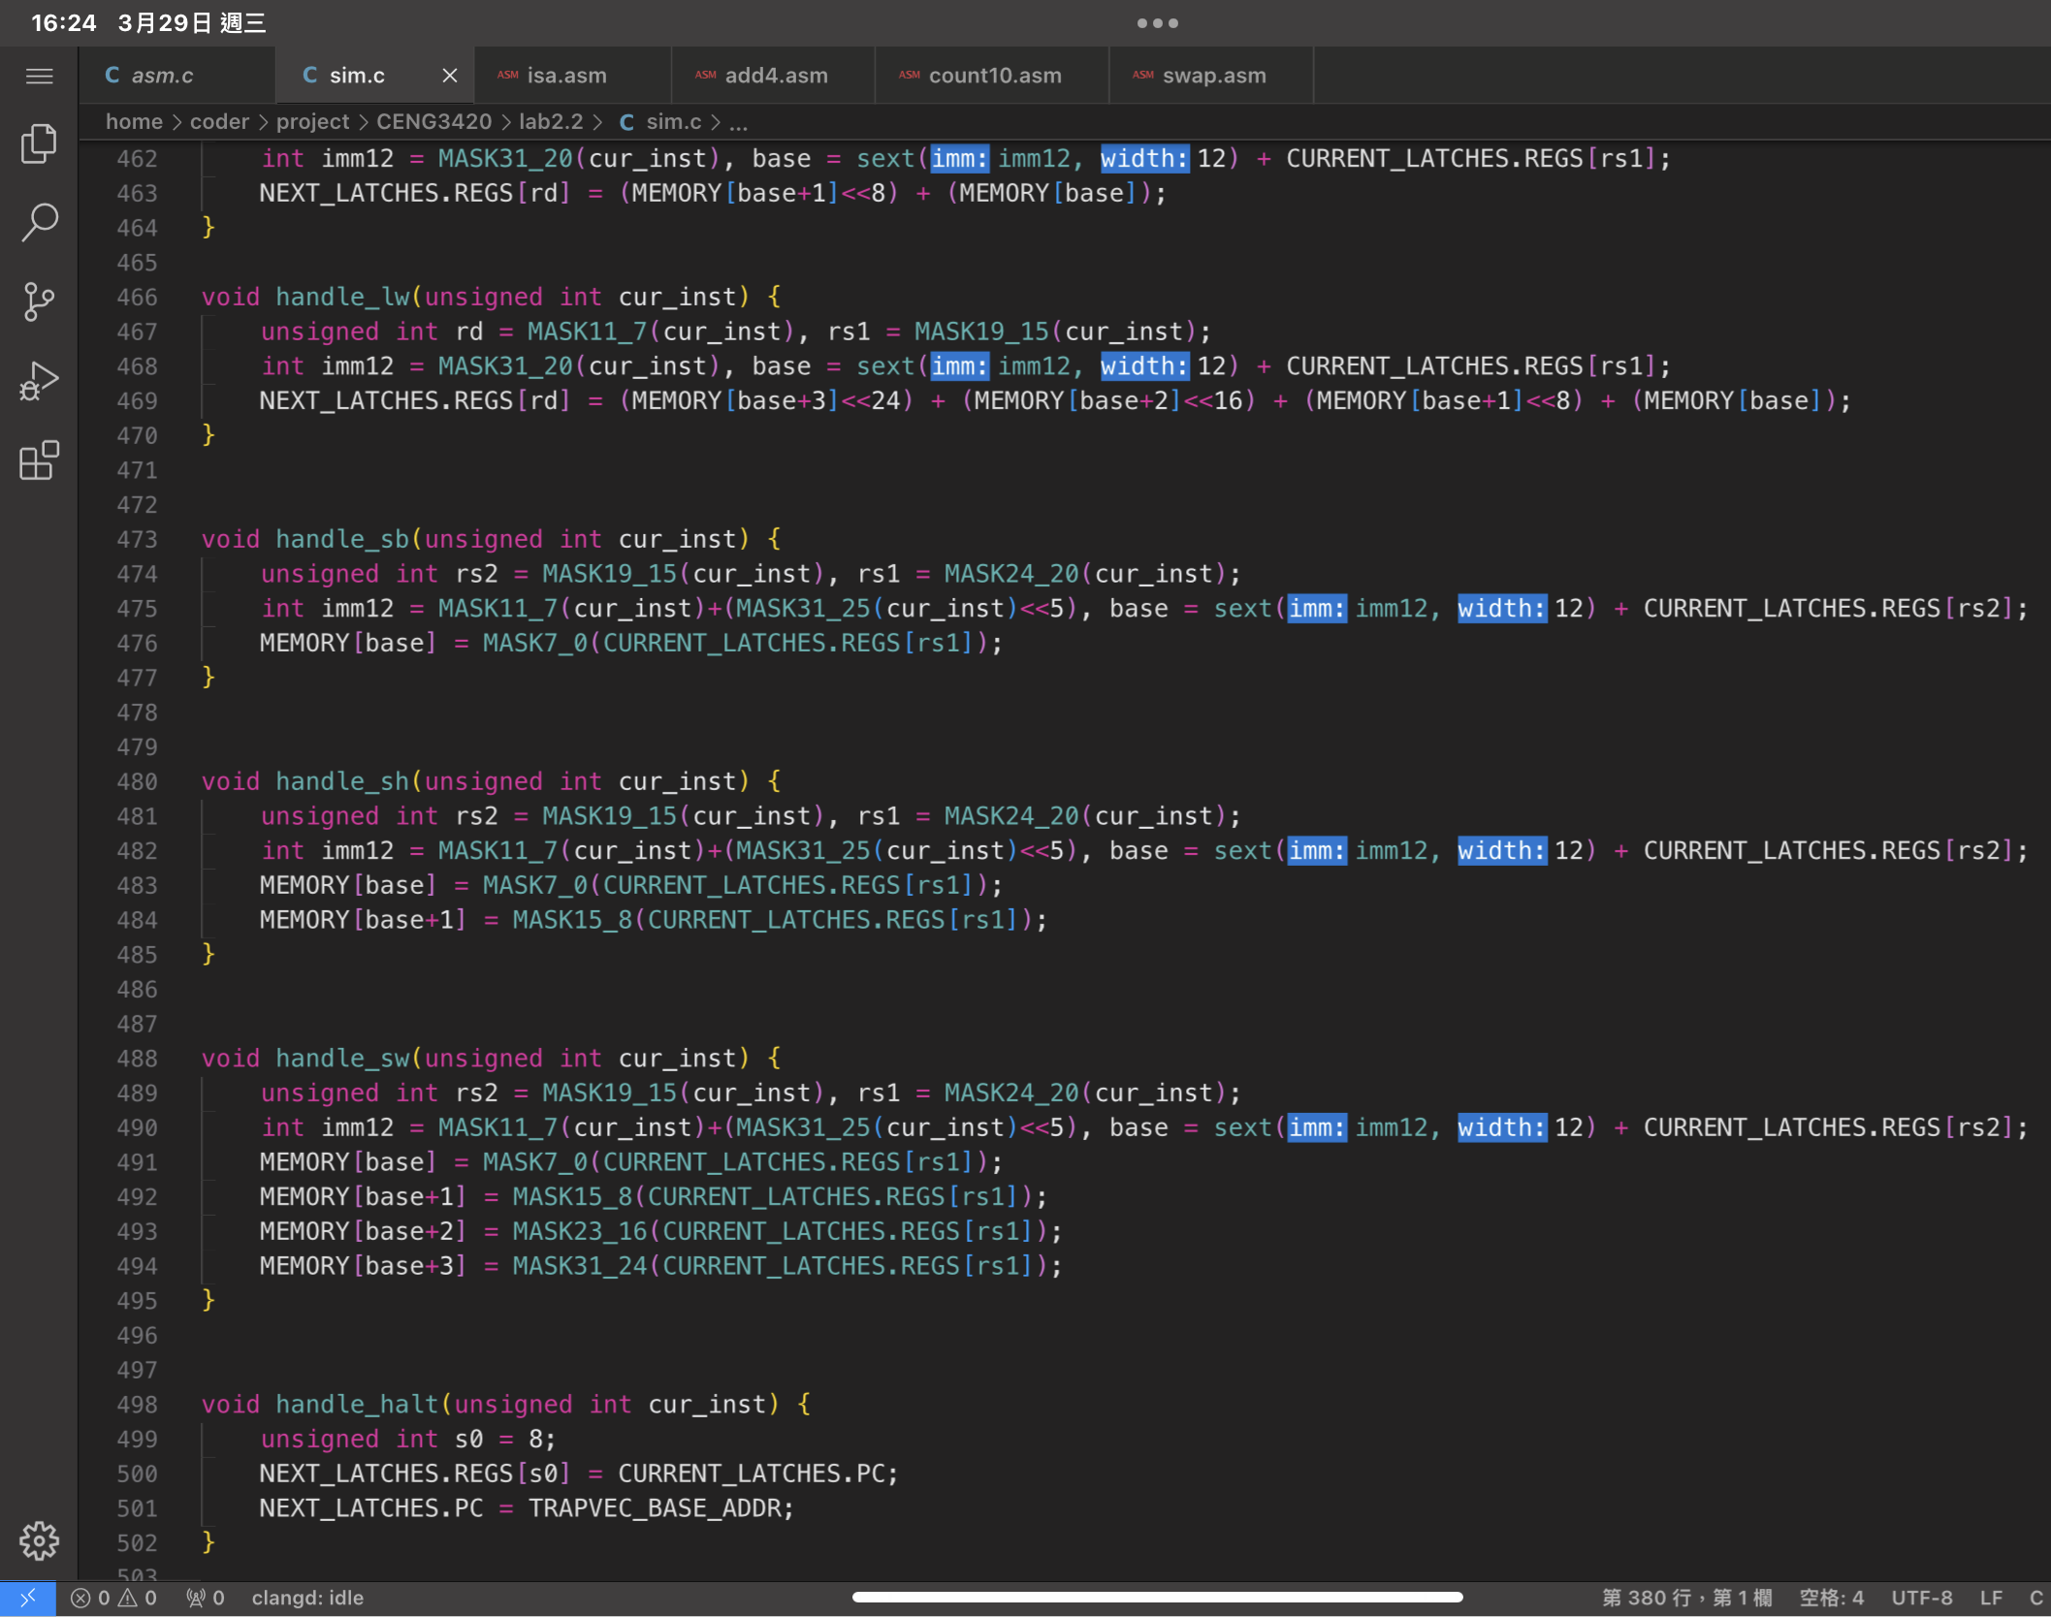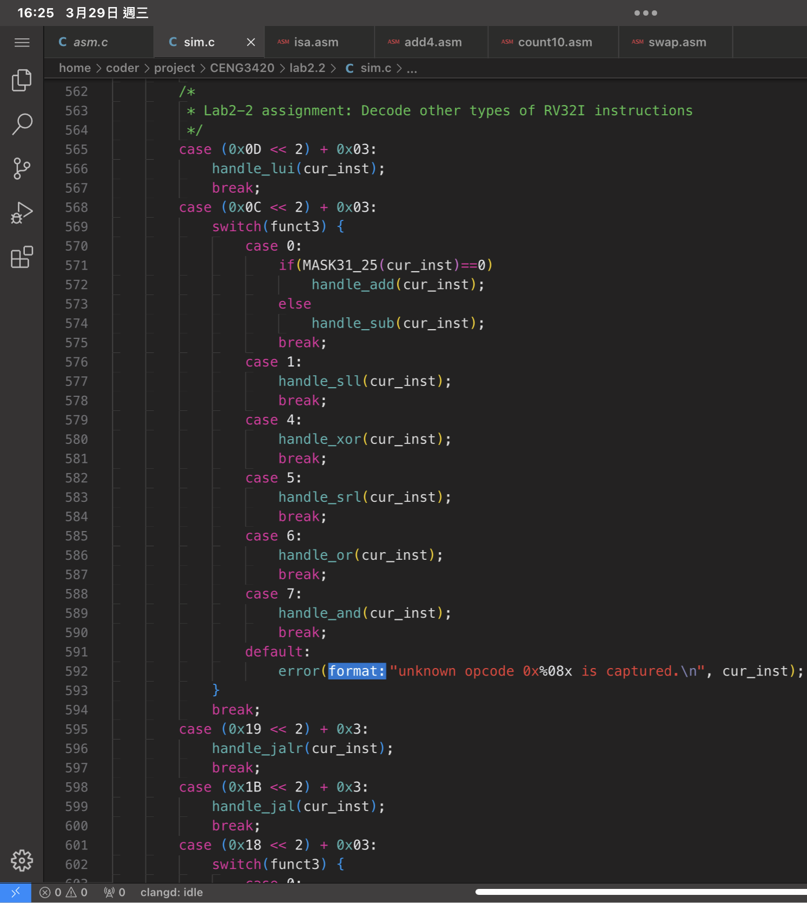

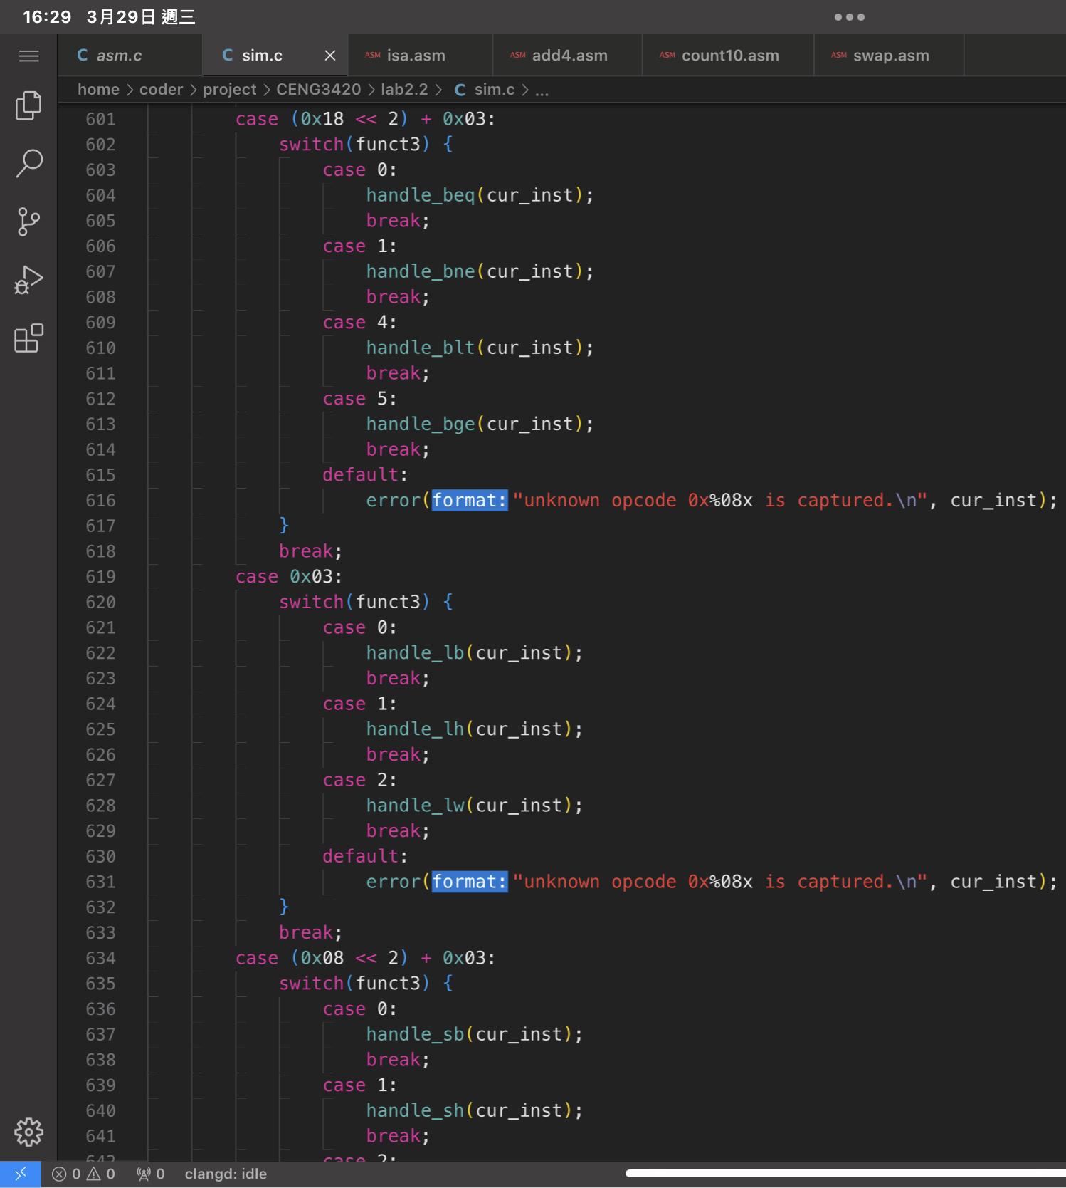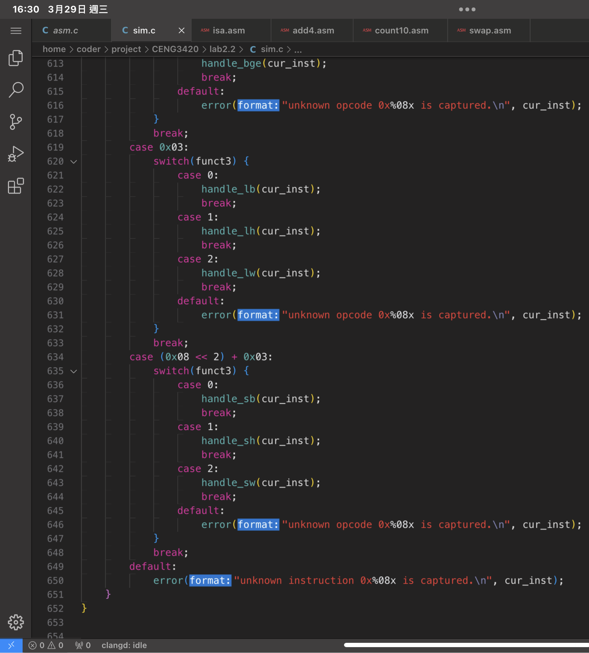

Console Output

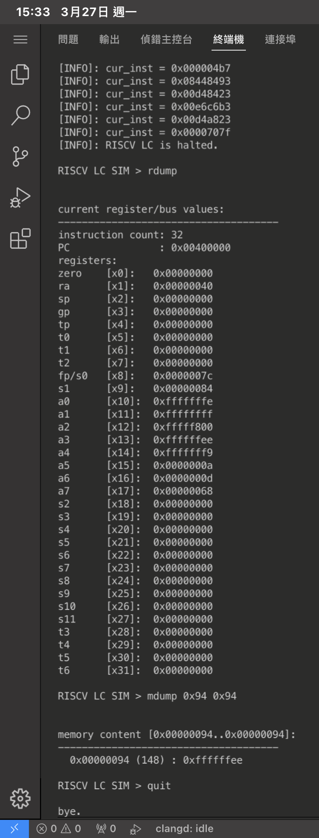Isa.bin:

Count10.bin:

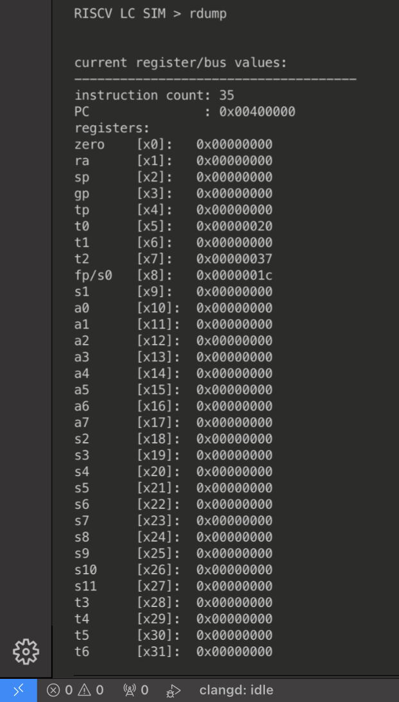

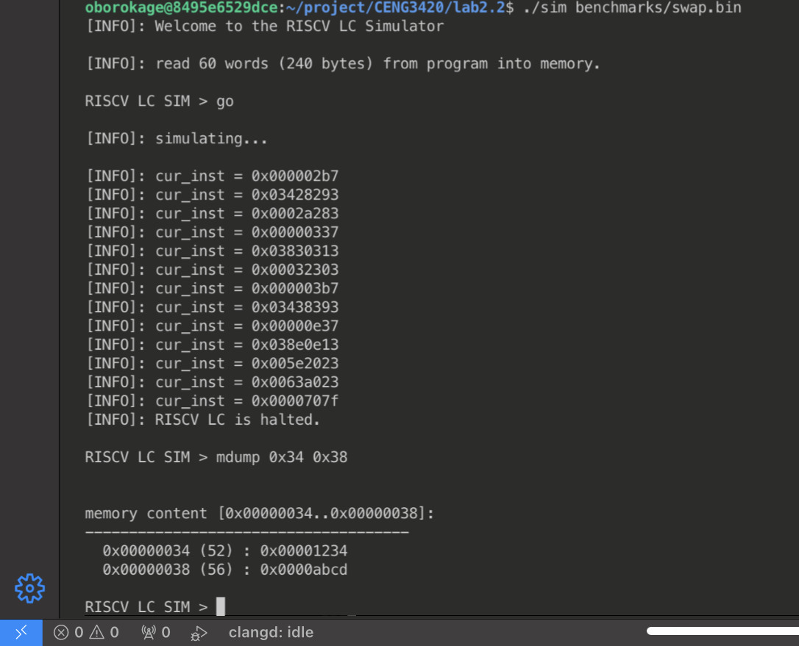Swap.bin:

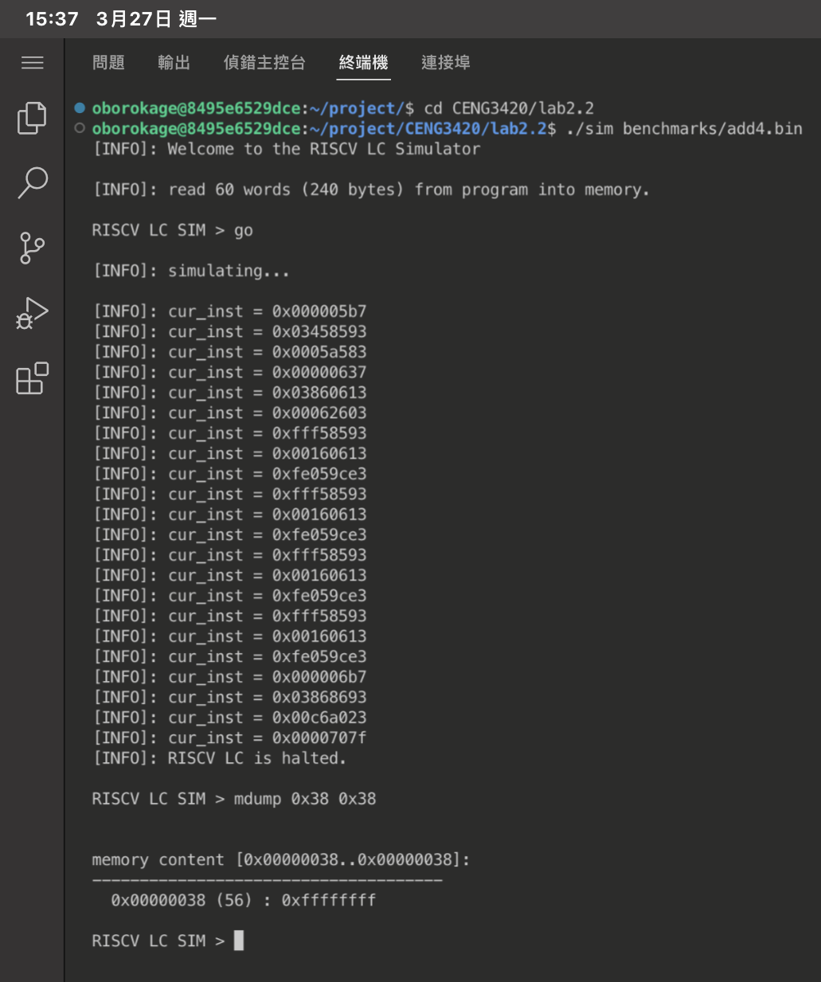add4.bin: